CPO Registration and Retail Process

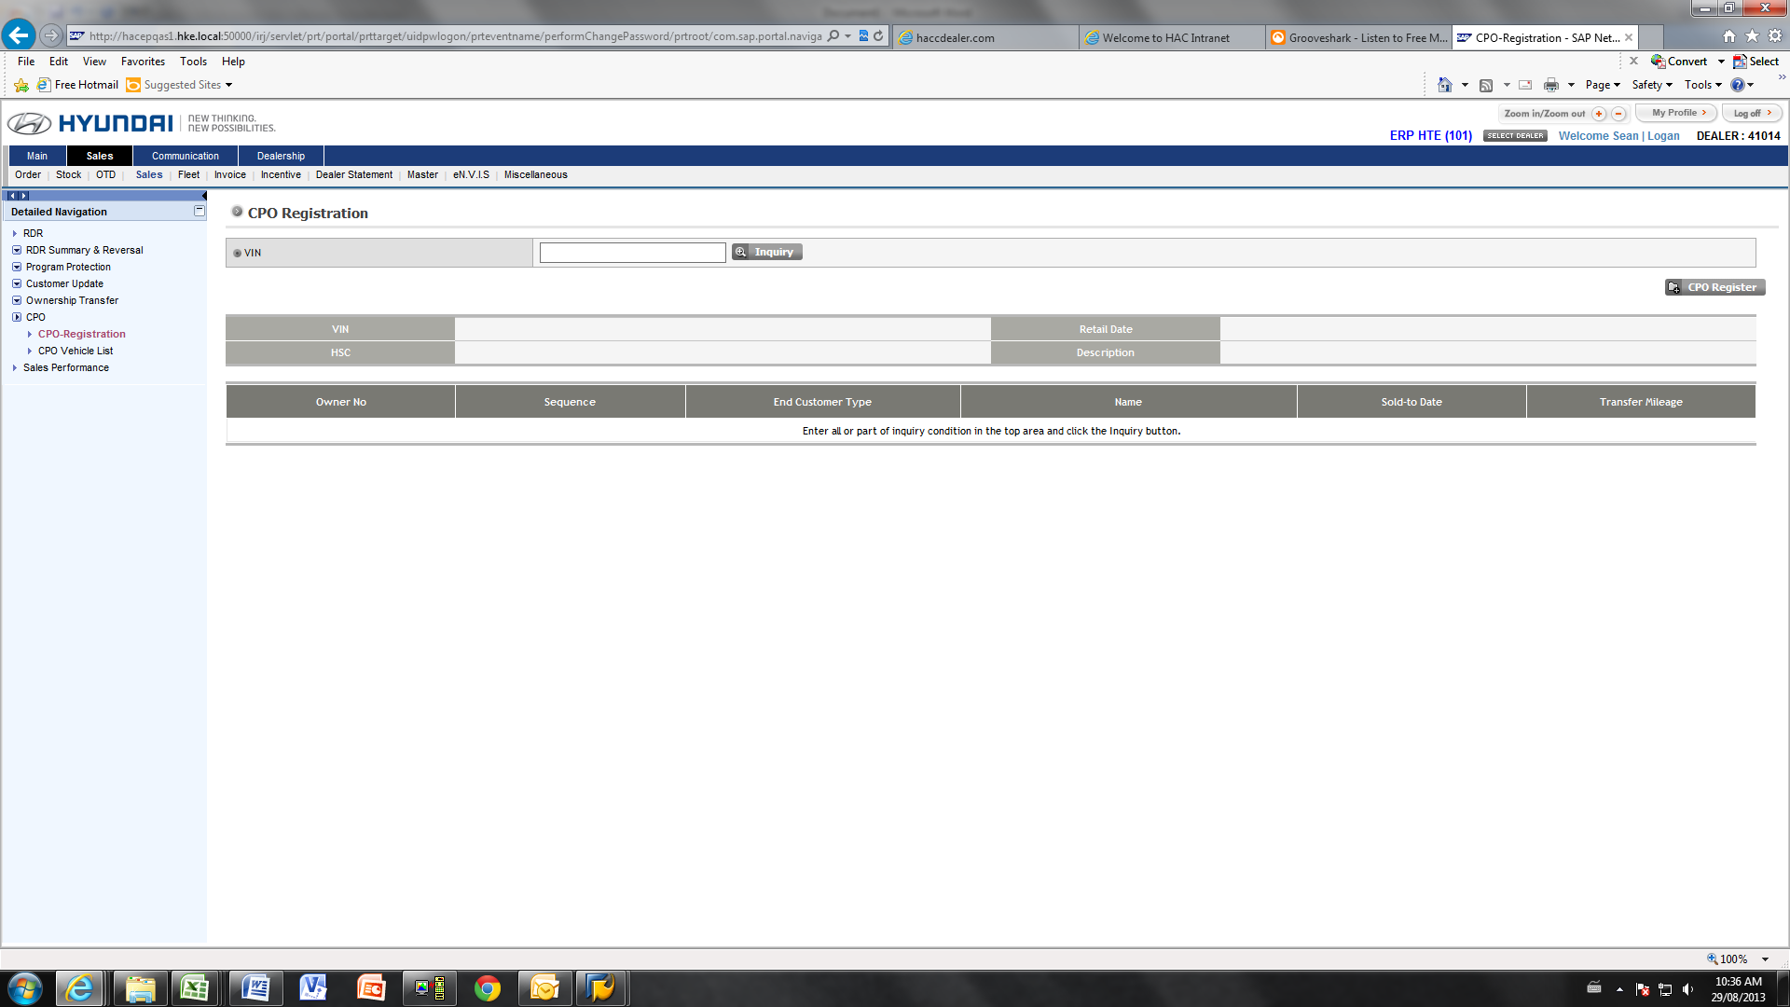

1. Click “Sales” from top Menu
2. Click “Sales” from sub-menu
3. Click “CPO” from Left hand Navigation. (This will automatically bring the user to the “CPO Registration” Screen.

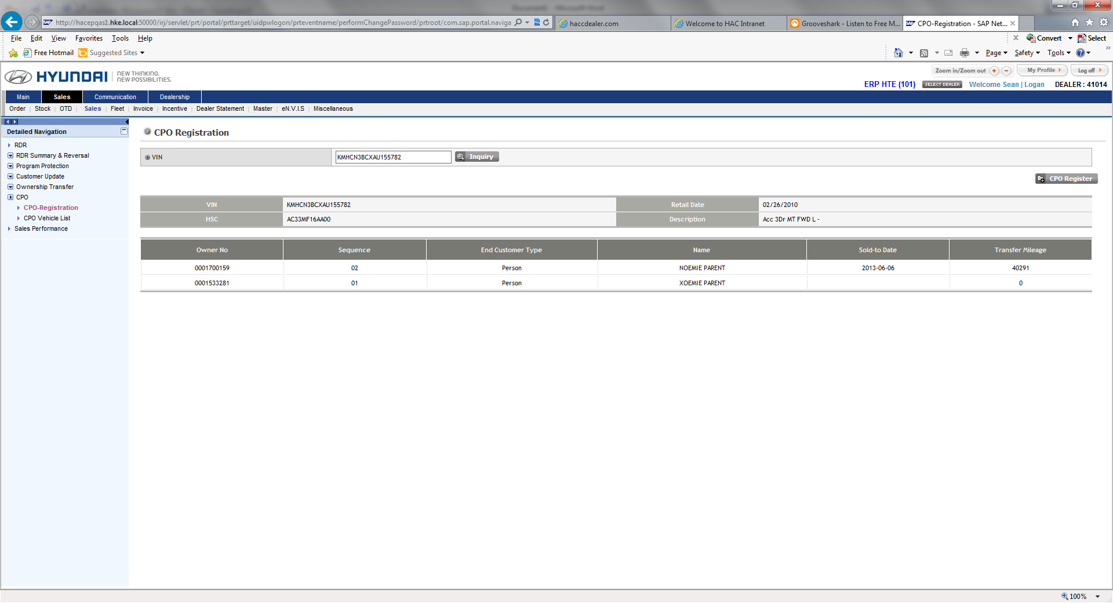

1. Input the vin of the Certified Pre-Owned vehicle and click “Inquiry”.
2. Click “CPO Register” button.

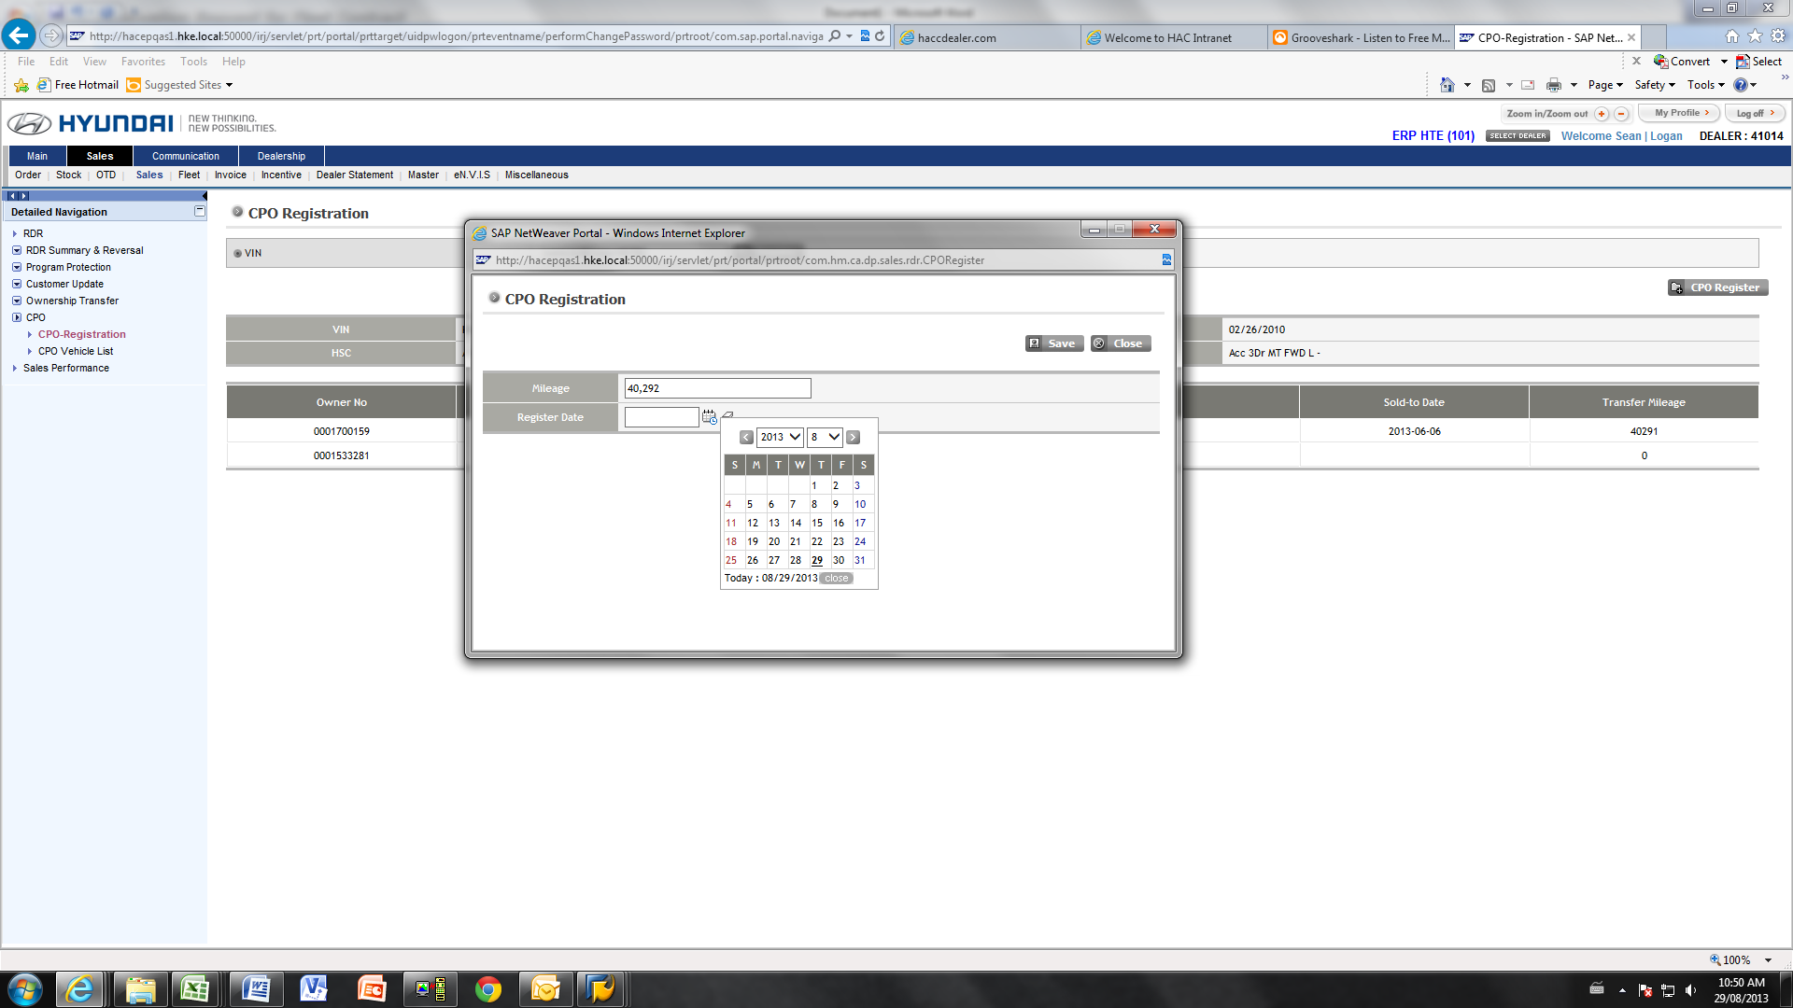

1. Enter the mileage of the CPO vehicles (must be greater than previous mileage entered in the system).
2. Select the registration date.
3. Click “Save” button. A message will pop up stating “Vehicle registration successful”

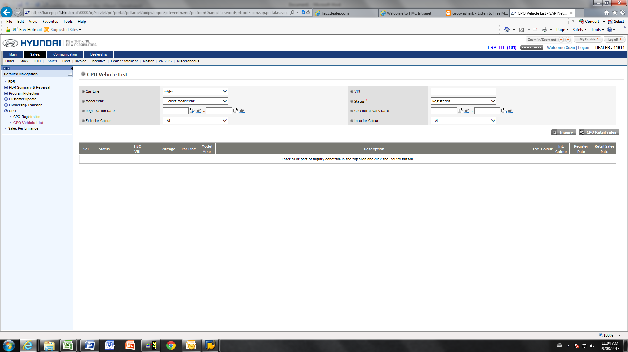

Now that the vehicle is registered as CPO, the dealer has the ability to retail this vehicle to a customer.

1. Click “CPO vehicle List” from the navigational menu.

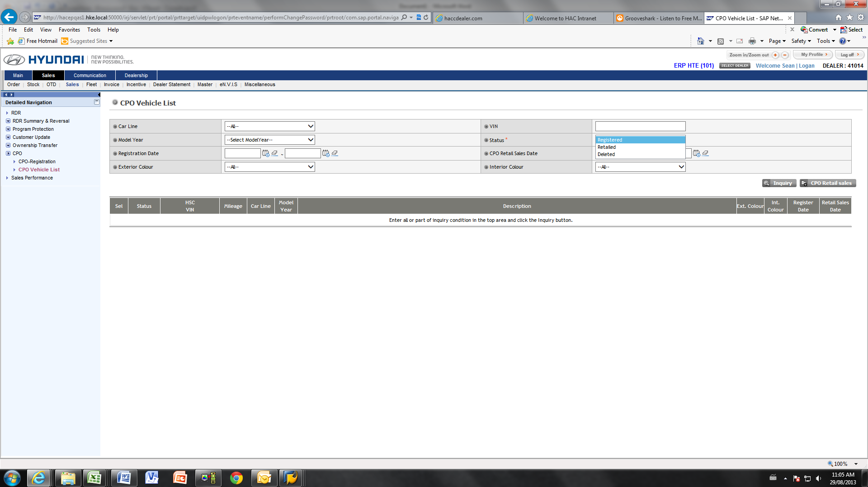

1. The dealer can now inquire into their own CPO inventory to find the correct vehicle to RDR.
2. There are several different fields that can be used to narrow down the inquiry.

* Carline -> Accent, Elantra, Sonata, Santa Fe etc.
* Model year -> Select the model year of the vehicle you are looking to retail
* Registration date -> Dealers can narrow down their inquiry based on the date the vehicle was registered as CPO
* Exterior Colour - > Exterior colour of the vehicle
* VIN -> Search for a specific vin number in dealers CPO inventory
* Status (required field) - > Registered (In CPO inventory), Retailed (CPO vehicle that has already been retailed to end customer), Deleted (deleted out of CPO inventory).
* CPO retail Sales Date -> If a dealer would like to inquire into previously retailed vehicle, they can enter the date range here.
* Interior Colour -> Interior colour of the vehicle.

1. After the dealer inputs all of the information into the above fields, click “inquiry” to display the vins that meet the entered requirements.

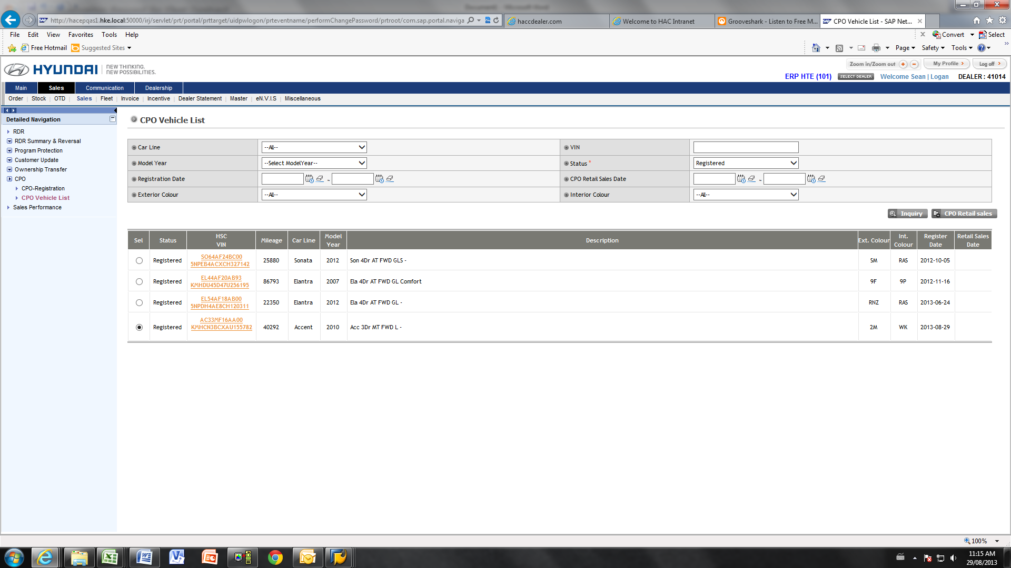

1. Locate the vin that is to be retailed. Select this vehicle by selecting the radio button.
2. Click “CPO Retail Sales”

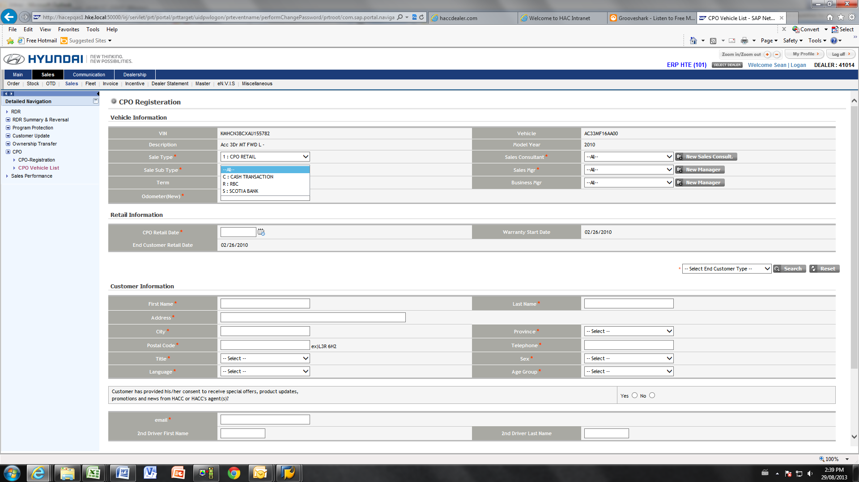

1. Select the Sales Type

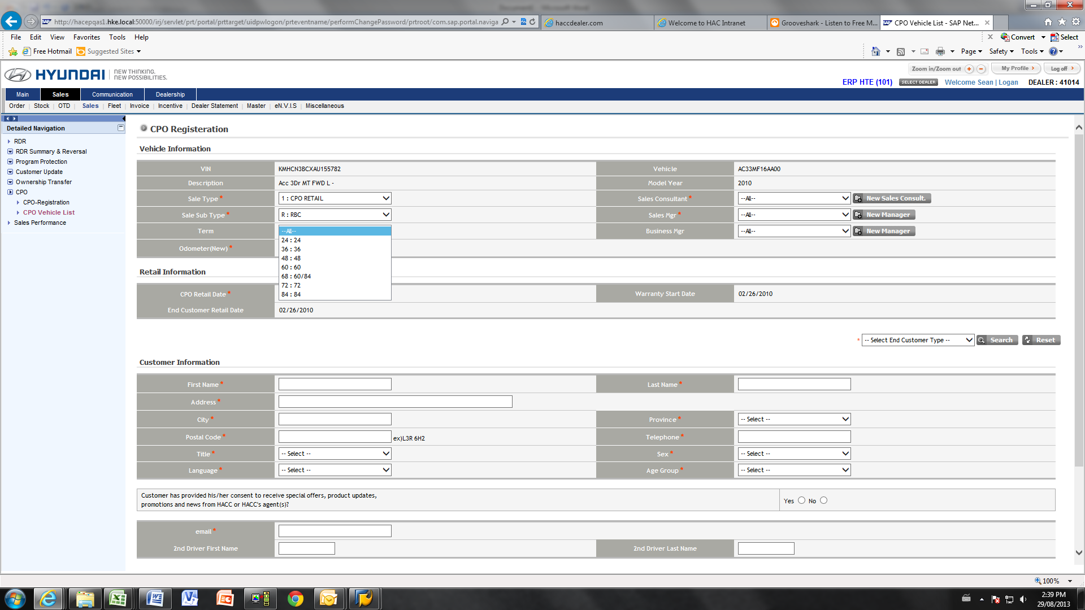

1. Select the term (if applicable)

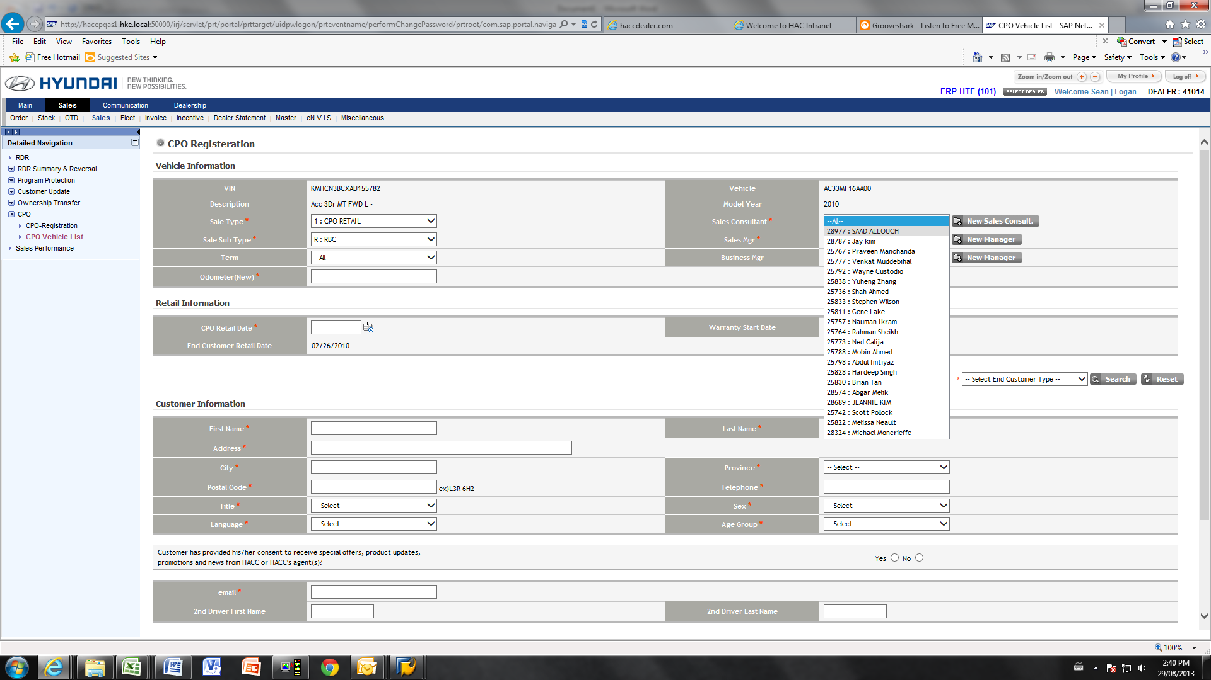

1. Select the appropriate sales consultant.

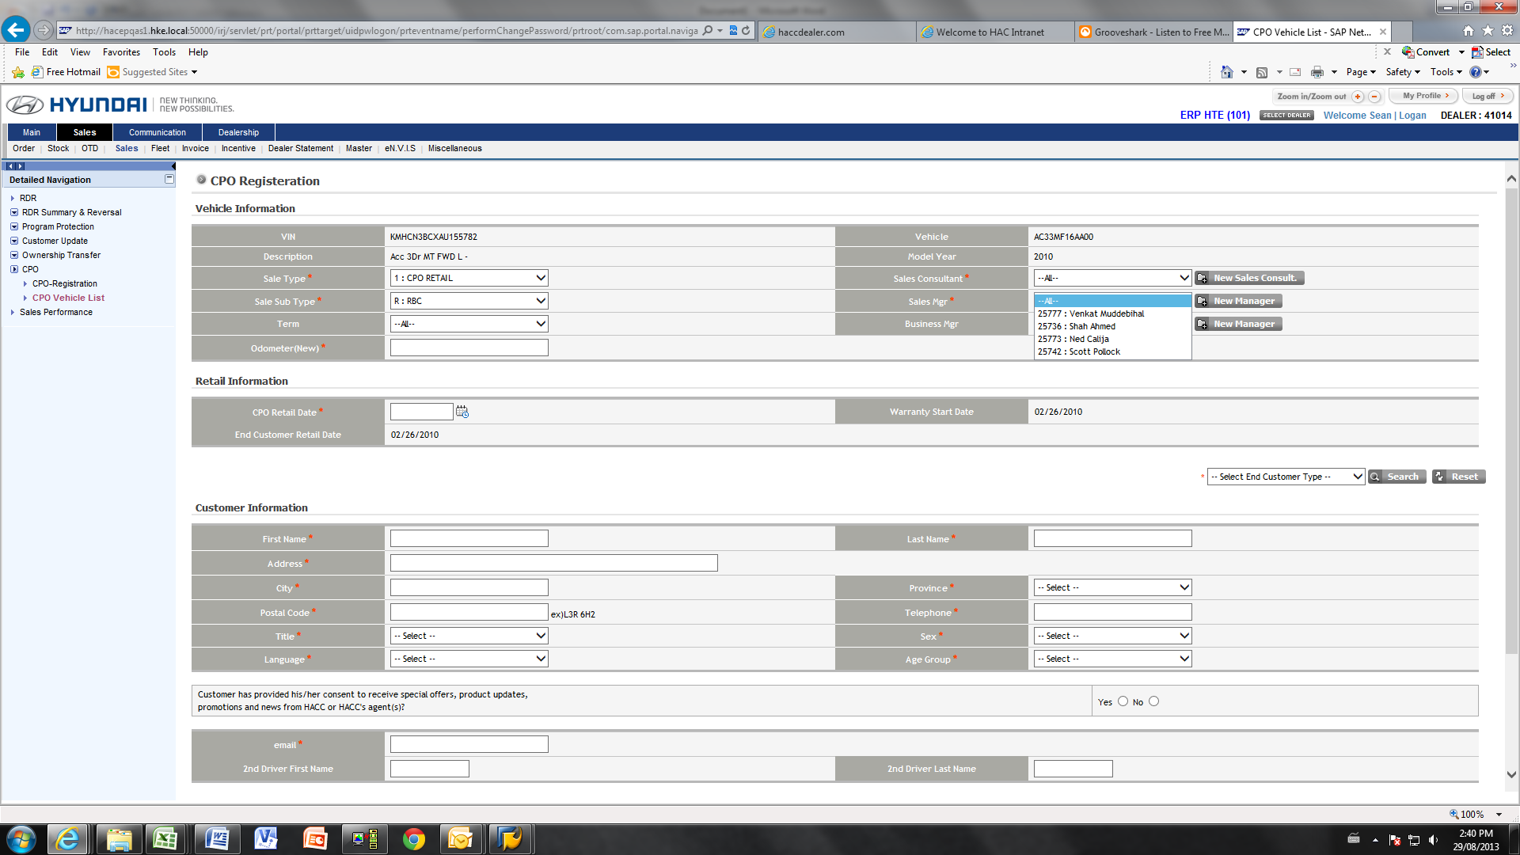

1. Select the appropriate sales manager.
2. Enter the odometer

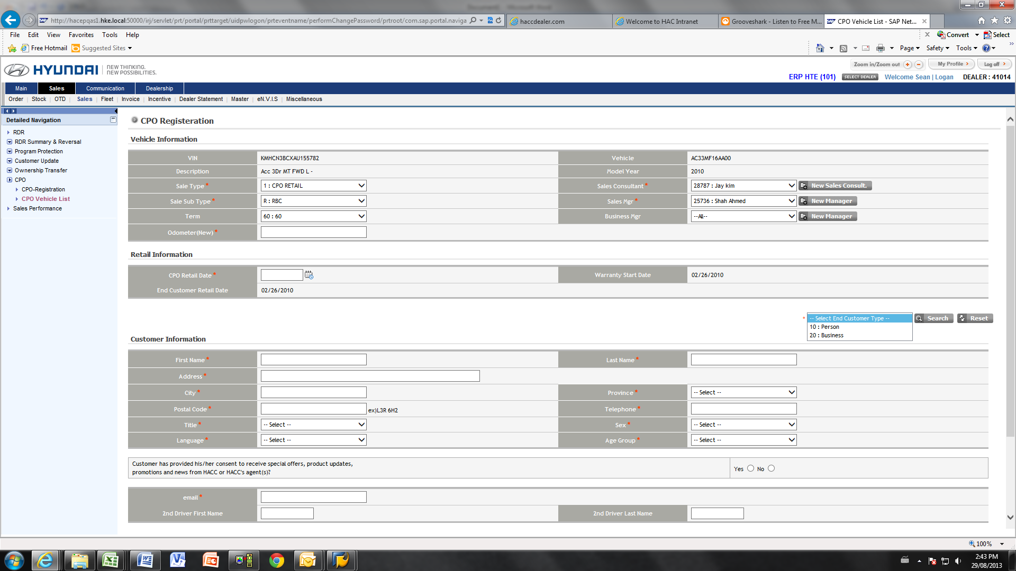

1. Select the type of customer.
2. Input the remainder of the customer’s personal information.

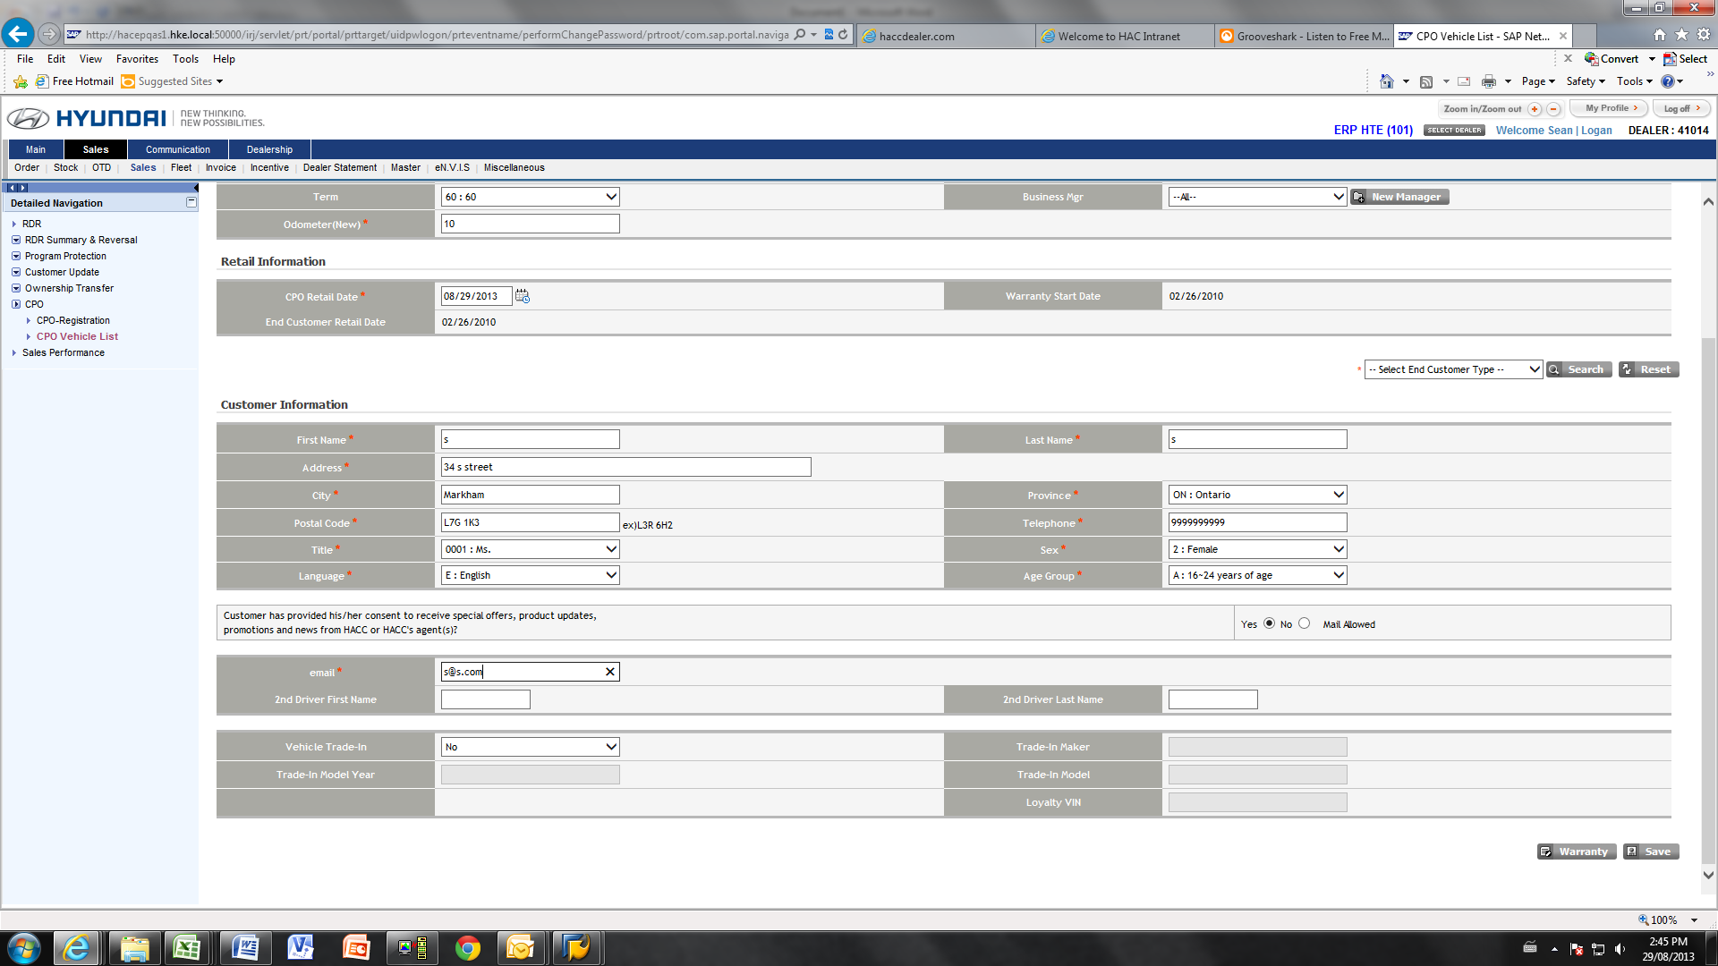

1. After all customer’s personal information is entered, click the “warranty” button.

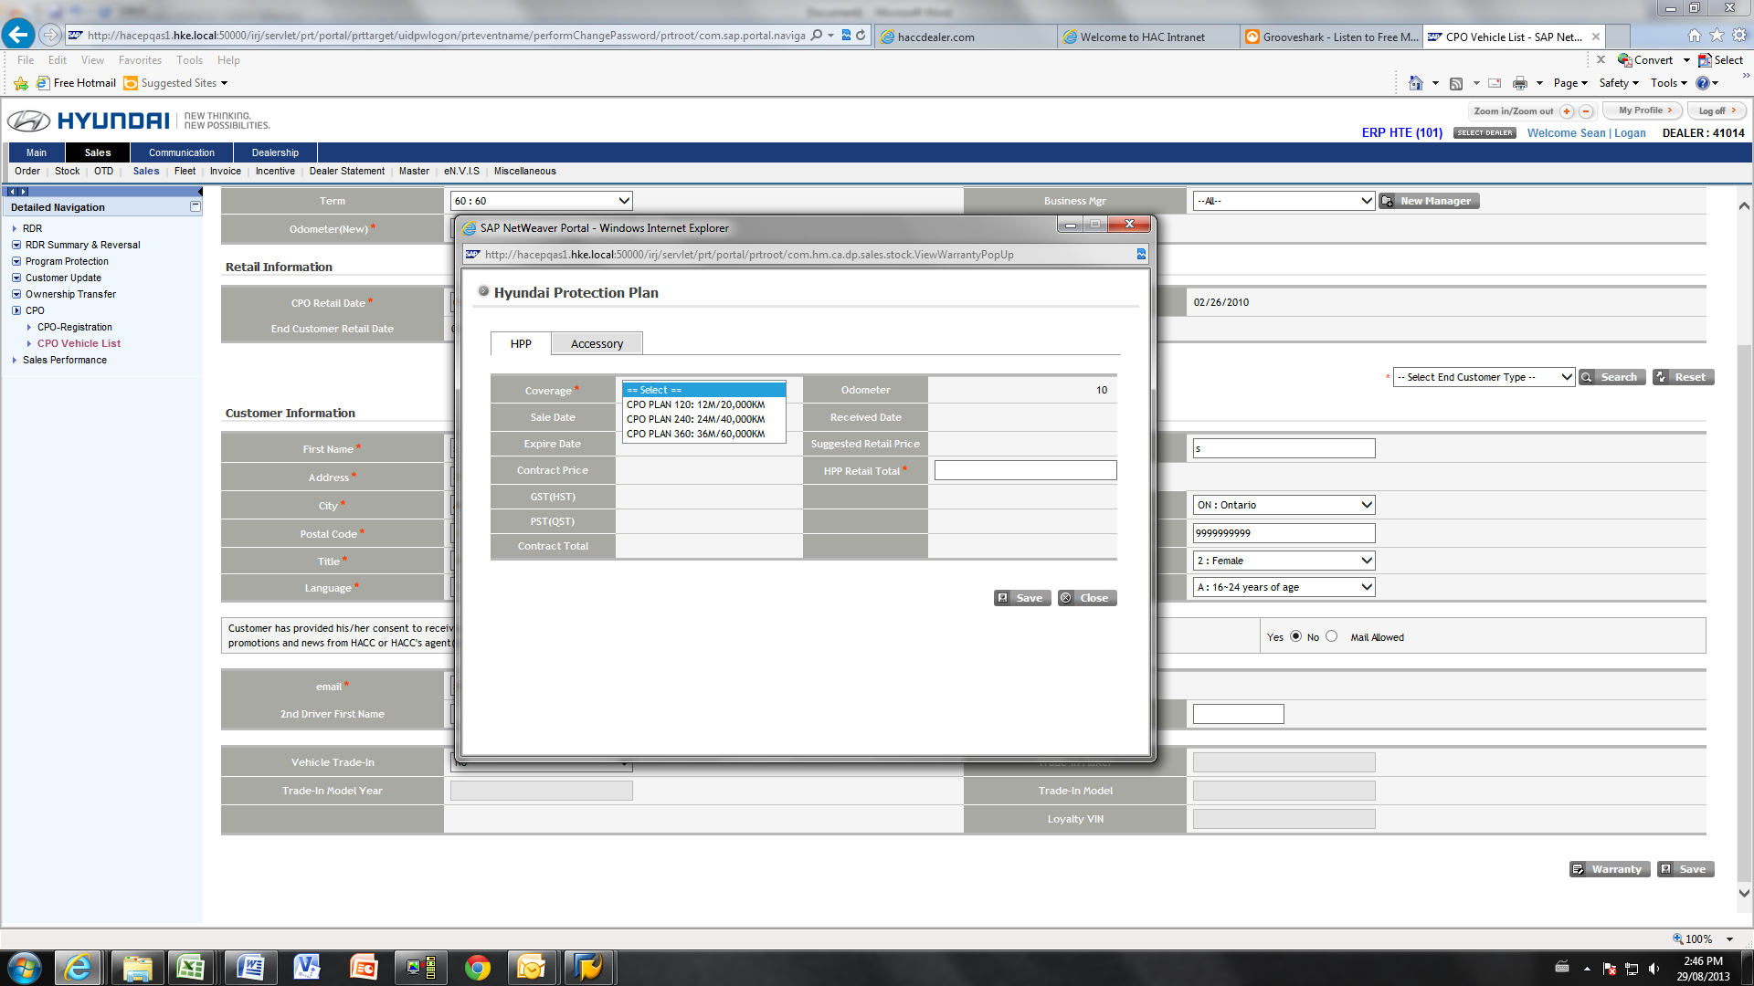

1. The above window will pop up. Select the appropriate coverage from the drop down menu.
2. Fill out the reminder of the required information and click the “save” button.

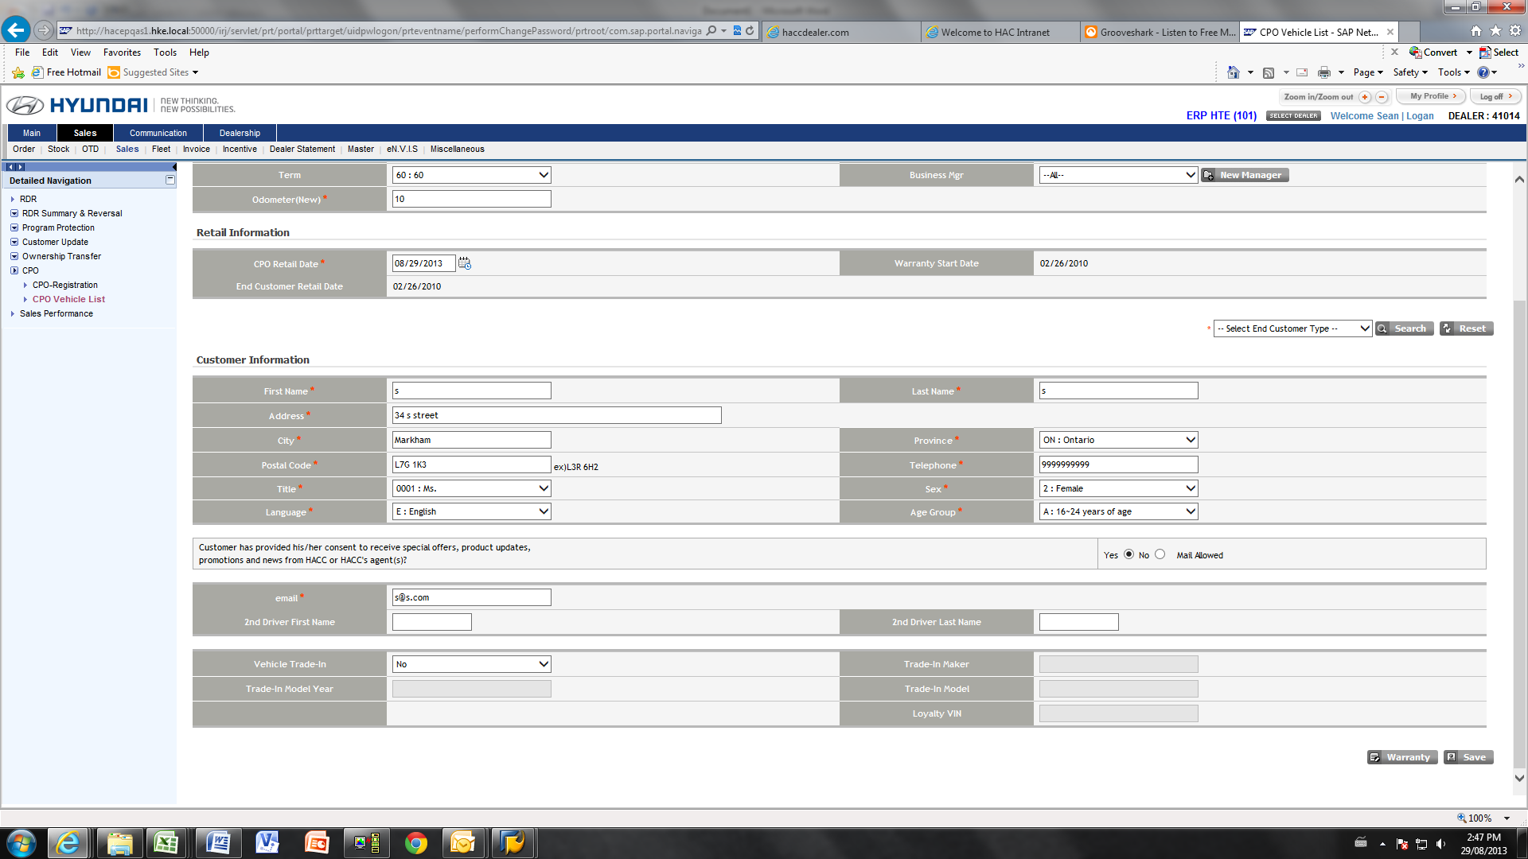

1. Click “Save”.
2. A window will pop up that says “Your process has been successfully completed”

Printing the Warranty Documents

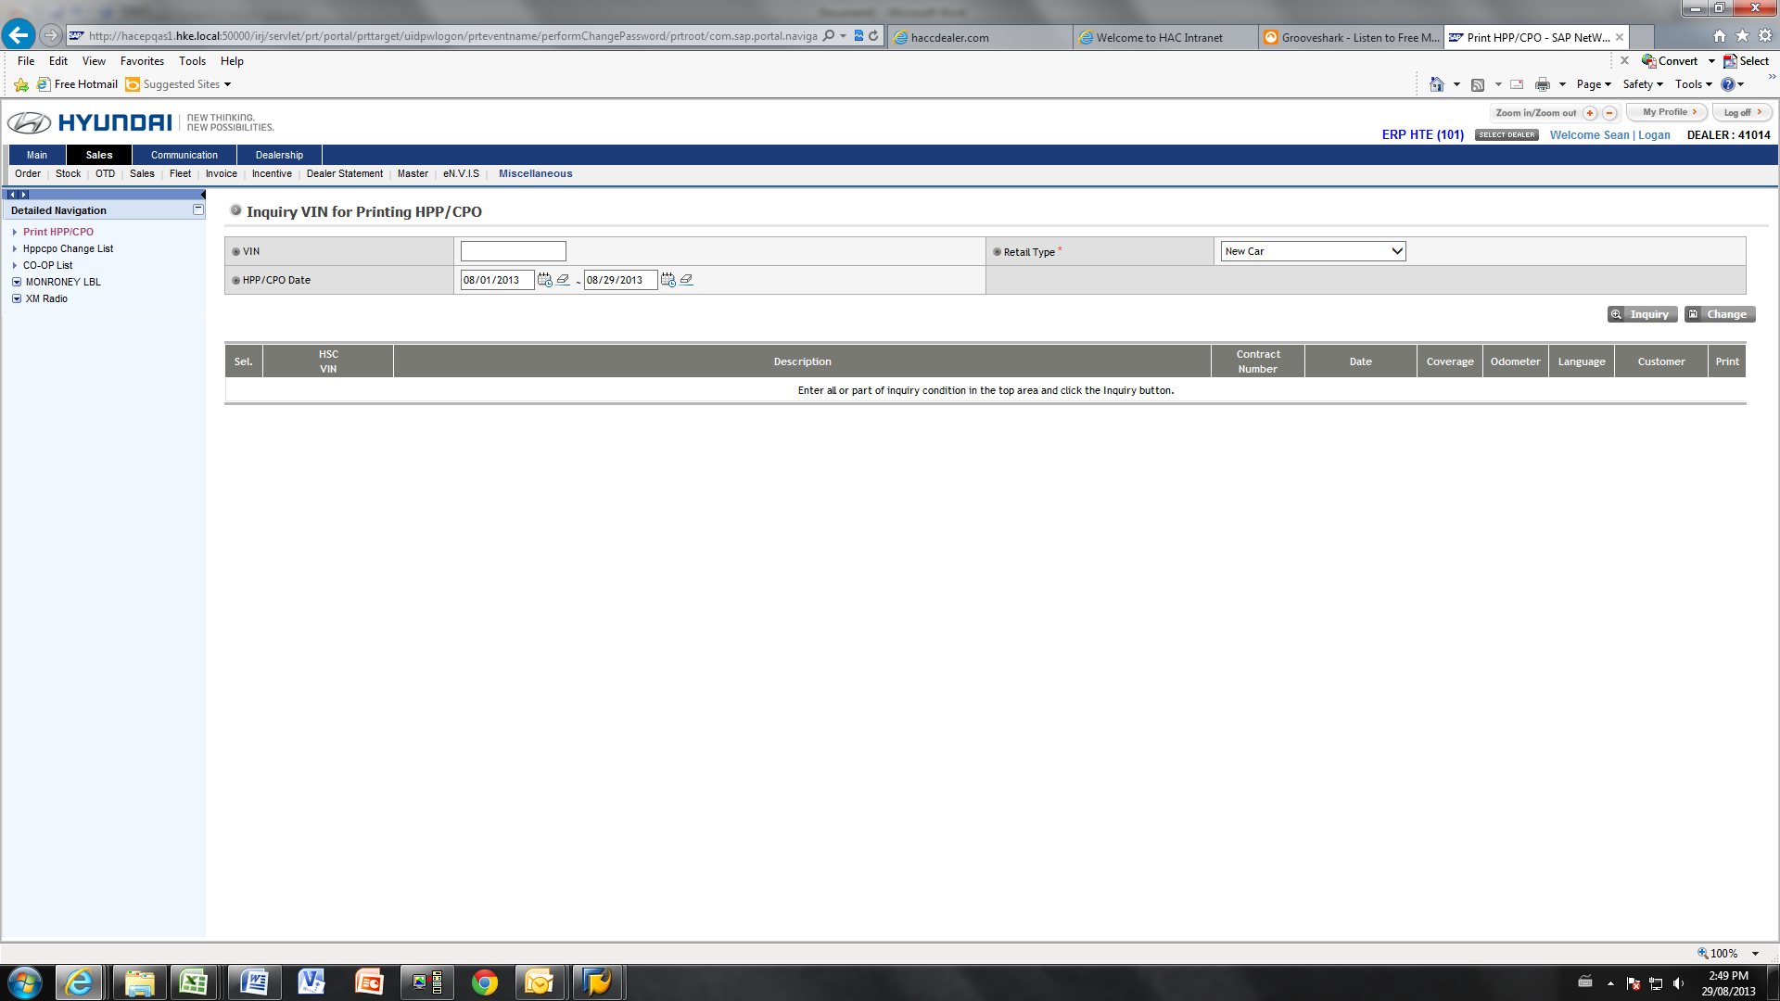

1. Click “Miscellaneous” from the Sales sub-menu.

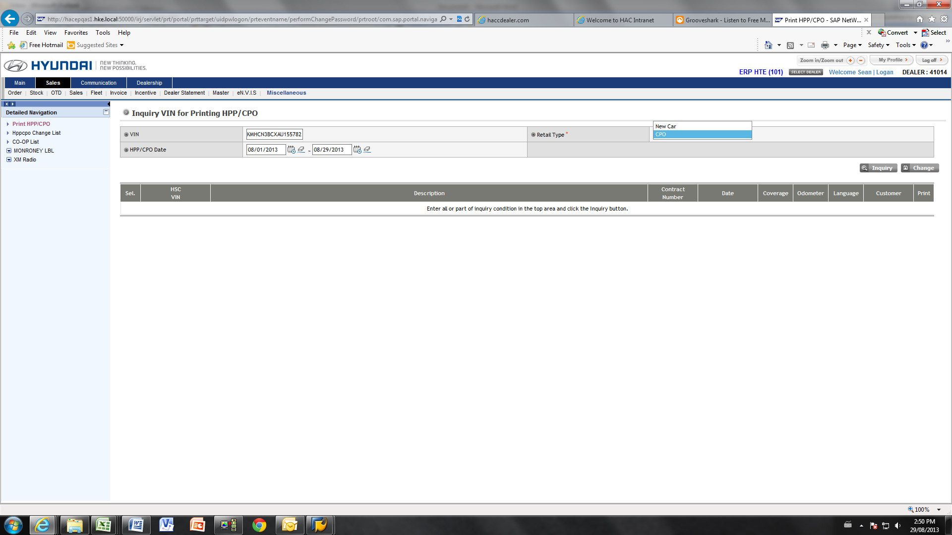

1. The page above will be displayed.
2. Enter the vin.
3. Select “CPO” as the retail type.
4. Select the appropriate date range that matches the sales date

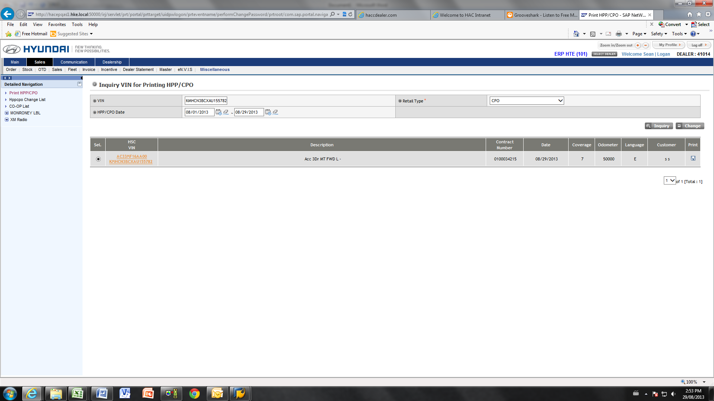

1. Find the appropriate vehicle in the list.
2. Click the disk under the “print” column.

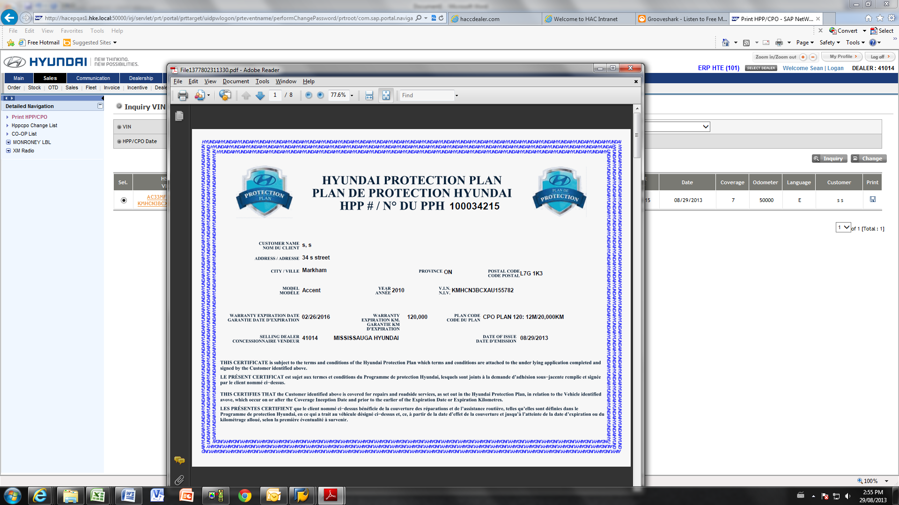

1. The warranty documents will be generated and can be printed by the dealer.